**Chapter – 3**

**DESIGN FLOW/PROCESS**

**3.1 FEATURES**

There are the following features of CUCHD Faculties Websites are:-

1. **User-Friendly System:** The interface of the system is user friendly and interactive. If any new student comes he /she can easily use the CUCHD Faculties website to find his / her required information about the faculty.
2. **Security-Management:** CUCHD Faculties web has good Security, for guarding information regarding the Chandigarh University faculty Members, only students of Chandigarh University and faculty members of Chandigarh university can access the information which will be presented on the website.
3. **Information-Handling:** CUCHD Faculties website has good user friendly interface which distribute the Information among the students and faculty members. The website clearly sorts the information between engineering department and Non-Engineering department and further it sort the information in respective of university blocks.

This gives the user too finally to look into required information with the blocks mentioned.

**3.2 CONSTRAINTS IDENTIFICATION**

The following Constraints come in the project:

1. **Time:** Time is the first constraint in designing the CUCHD Faculties website. Time is a key element to a project’s success. After all, what good is a finished product if it is completed long after the expected deadline? To overcome this constraint our project team first design the time table and divide the project according to the time table. Time Management also helps in increasing the speed of the project.
2. **Quality:** Quality is another constraint that the system has. The quality constraint focuses on the characteristics of the deliverable or product. In general, the quality of the project will be evaluated by how closely the outcome matches the expectations set in the planning stages.
3. **Students Satisfaction:** Another constraint to bear in mind is customers/students satisfaction. When thinking about customer satisfaction as a constraint, our team needs to keep in mind that we design a simple and interactive user interface. So to overcome this constraint we add JavaScript to the website for a responsive and interactive look.
4. **Resources:** Resources is one of the constraints that we face in designing the project. To avoid the effects of this constraint our team takes help of Google, teachers, friends and also collects the resources from different other websites.

**3.3 ANALYSIS OF FEATURES & FINALIZATION SUBJECT TO CONSTRAINTS**

Despite having a lot of constraints and risks, till now, we have achieved the feat of minimizing them and we hope to do so in the upcoming phases of the project. After analyzing all the aspects of our project i.e. features and possible constraints, we have decided on certain features for our project that will be suitable.

Major among them are listed below:

**Live Chat:** A live chat or AI chat is a feature where your operators initiate the chat and reach out to your website visitors by offering instant help. This is a powerful tool for increasing customer satisfaction and engagement.

**Data Extend & format:** In feature updating the website our team make plane for adding new data, categories and voice searching for making the web smooth and attractive so that range of students/users is increase in the website.

**Analytics and reporting:** Analytics gives you visibility into key areas of your operation and is arguably the most defining feature of the software. We can use analytics to know which problems to attack first. We can analyze this using Customer or user data, time spending and menu analytics and Inventory and procurement analytics.

**3.4 DESIGN SELECTION**

The CUCHD Faculties system is designed based on a mixture of multitier architecture, RESTFUL architecture style [5] and Model View View Model (MVVM) pattern [7]. The multi tier architecture provides a model to create flexible and reusable components in a web application. It segregates the application into several tiers, where developers can add/modify the functionalities on a certain tier instead of modifying an entire application. This allows the functionalities of the system to extend for future development.

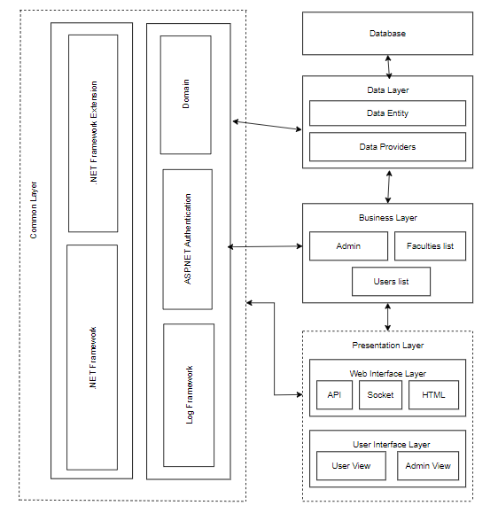

Figure 3.4.1[Component Diagram]

The RESTFUL architecture style provides core functionalities of the system as web services for different devices and platforms as mentioned in requirements R1, R2 and R5. The MVVM pattern [7] allows developing the User Interface (UI) with clear separation of UI components and presentation logic. The core system has three main layers: Data Layer, Business Layer and Presentation Layer. The Presentation Layer is further divided into two layers, namely Web Interface and UI Layers. These two layers are loosely coupled and connected with web services. All these layers are cross-connected with the Common Layer, as shown in Figure 4.1.

* + 1. **DFD OF THE SYSTEM:**
* Level Zero Diagram:

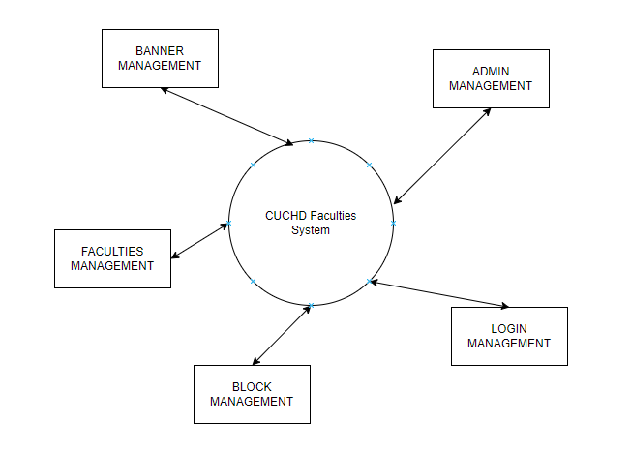

Figure 3.4.1(a)[Level Zero DFD]

* Level One Diagram:

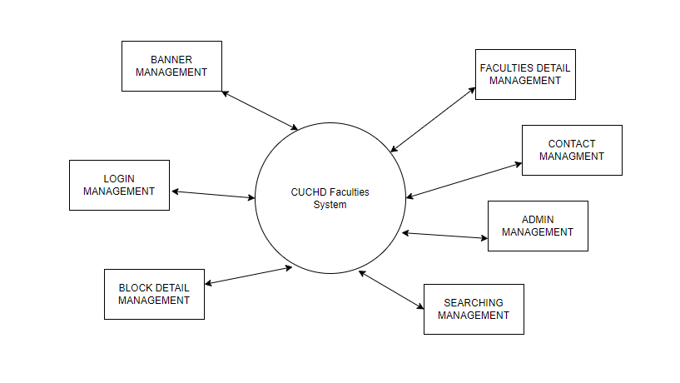

Figure 3.4.1(b)[Level 1 DFD]

* Level Two Diagram:

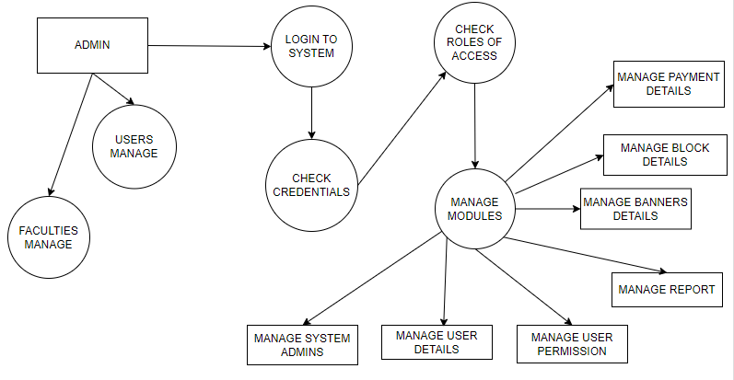

Figure 3.4.1(c)[Level 2 DFD]

* + 1. **Use Case Diagram:**

Use-case diagrams describe the high-level functions and scope of a system. These diagrams also identify the interactions between the system and its actors. The use cases and actors in use-case diagrams describe what the system does and how the actors use it, but not how the system operates internally.

Here users and admin are the actors and the working of the system is use cases.

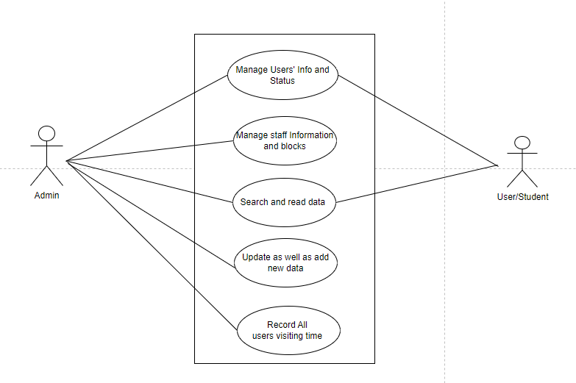

Figure 3.4.2(a)[use case diagram]

* + 1. **Sequence Diagram:**

A sequence diagram is a type of interaction diagram because it describes how—and in what order—a group of objects works together. These diagrams are used by software developers and business professionals to understand requirements for a new system or to document an existing process. Here this sequence diagram shows how the system works in step by step.

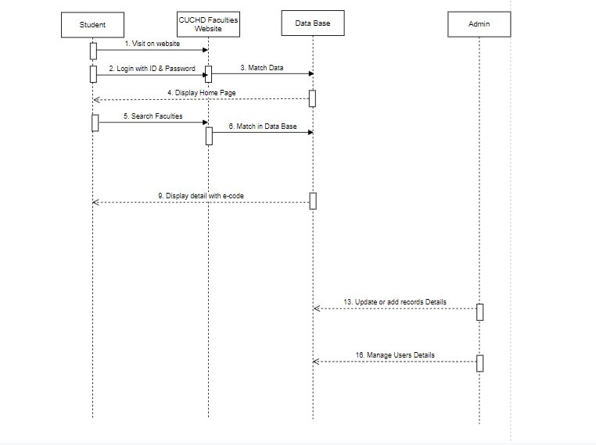

Figure 3.4.3(a)[Sequence Diagram]